Building vRTM & Measurement Agent

Following process is same for Ubuntu 12.04, Ubuntu 14.04, Fedora20, RHEL 6 and SuSE Linux. Each platform’s build has to be created over the same build linux flavour build machine.

* Check out the latest source code of vRTM (/root/vrtm) & the measurement Agent(/root/verifier) onto the build system.
* If you are using the standard repository naming convention, then this step for exporting the Measurement Agent folder is not needed. In our example, we are using non-standard folder structure. So, we have to do export the location of the Measurement Agent source code. This is done so that before vRTM is build, even the Measurement Agent would be built and copied to appropriate folder where the vRTM expects it.
  + export TBOOT_REPO="/root/verifier/"
* Browse to the /root/vrtm/build folder. Update the permissions of all the scripts if needed.

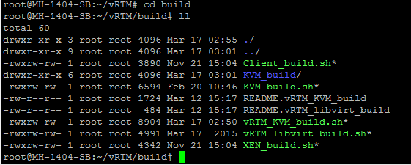

* Run the following command to ensure the script does not have any special characters. No need to run this command on other scripts since this script would run dos2unix on all the scripts.
  + dos2unix vRTM_KVM_Build.sh
* Before executing the build script, please ensure the internet connectivity as the build script downloads and installs packages in the process.
* Now run the "vRTM_KVM_Build.sh" script to build the vRTM image. If you are running this for the first time, it would take approximately about 5 min to complete the build.

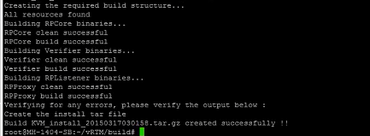

* Verify that the image and the script to run the image are created in the /root/vRTM/dist folder. For installing it on the host, need to copy these 2 files on the target host and run the vRTM_KVM_install.sh script.

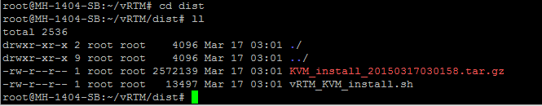

* If vRTM is already installed on the host, ensure that the corresponding process is stopped before installing the new version. To find if there is another version of vRTM already installed look for processes starting with rp_ as shown below. Another option is to look under the /opt/RP_* folder.

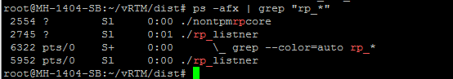

* For installing the vRTM, run the vRTM_KVM_install.sh script. You can choose the default installation folder, enter the IP address of the machine and choose "nontpmrpcore" option when prompted for.
  + Note: The script would be updated so that user need not provide these inputs and can be automated.

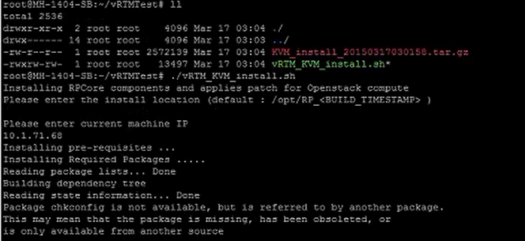

* After successful installation, ensure that vRTM is running by looking at the processes that are currently running. You should be able to see one nontpmrpcore process and one rp_listener process.